WEB Site How to Use
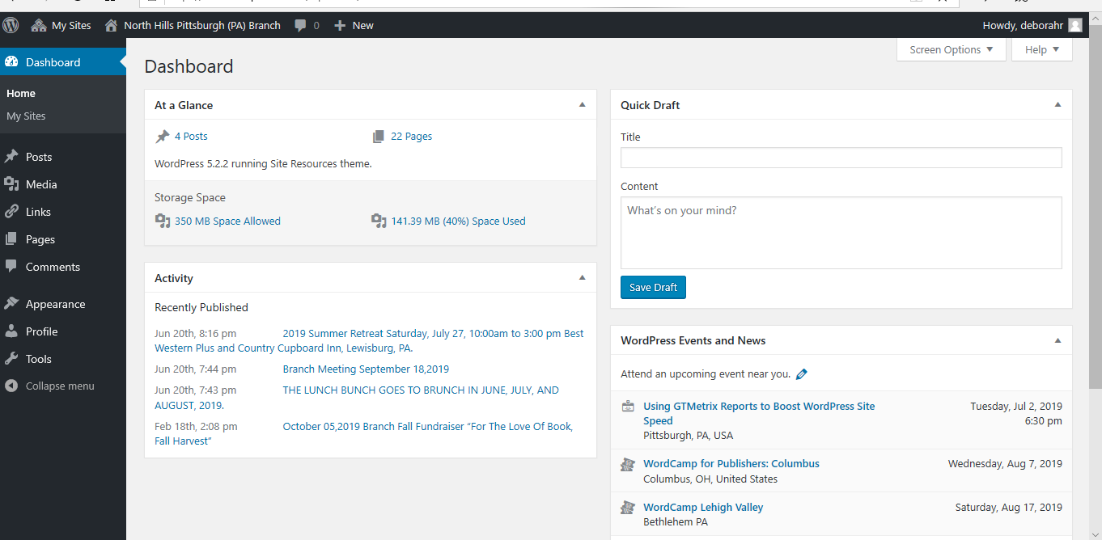

Post
To Add new post, click on Add New
Add tile and paragraph about the event

Media
The library of documents are housed under media
To add a viewpoint, it must be uploaded here first

Helpful hints
To Copy use: ctrl C
To past use: ctrl V
To cute use: ctrlX

