Posts
These two images show the steps to add a post to the Posts list.
- Start by clicking the Add New link to put up a new post.
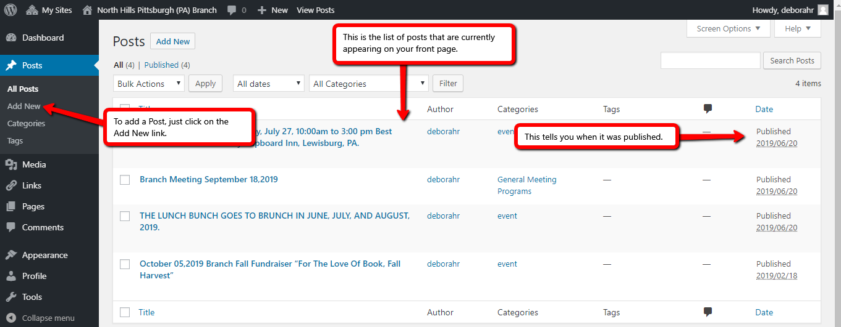
When the New Post page opens you need to give your post a title and then add the content.
Once you are finished…remember to Publish…this is located on the right side of the screen.
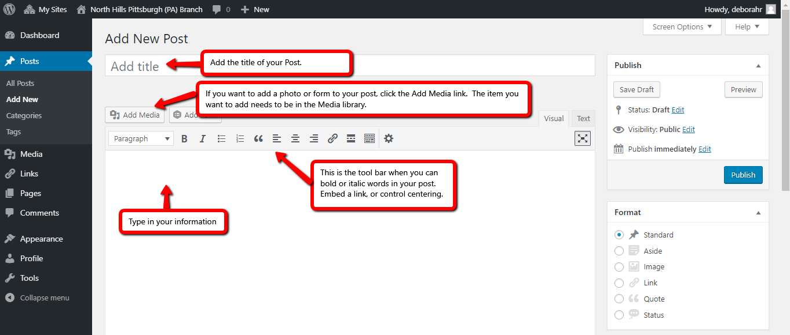
You can add pictures or embed links into your posts. You do that by clicking on the icon on the tool bar.
You have set the default for Posts to show 3 posts at one time. Posts appear in chronological order by publish date.

To edit or delete a post…you place your cursor on the title of the post…the edit menu will appear below it. Select Edit to make changes to your post, or select Trash if you want to delete existing or older posts.
