Pages
When you click on the Pages link from the side menu, you will see a list of all the pages that have been made for your website. Some may be published, while others are in draft format. You can see the pages that are Drafts…it will say Draft next to the page title. It will also display a Modified date versus a Published page. You can also see who the Author of the page is if multiple persons have access to make pages.
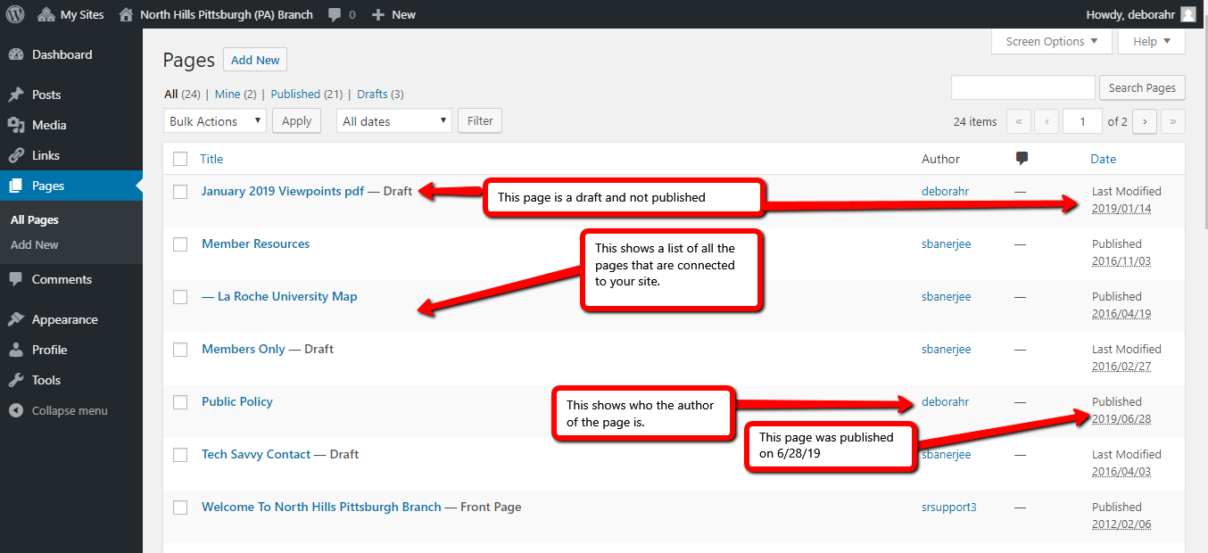
To add a new page…click the Add New link at the top of the page.
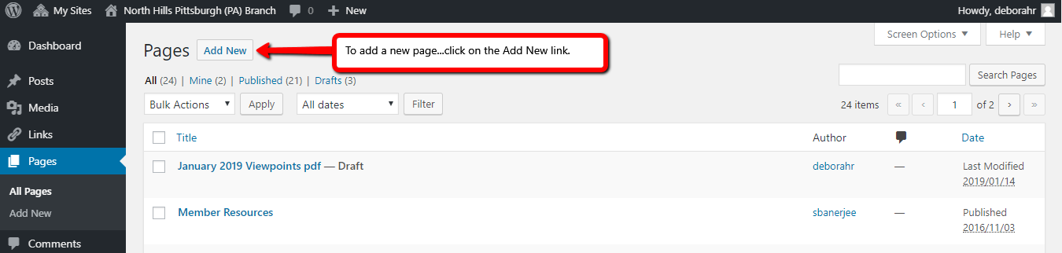

Once the New Page screen opens, you can add the Title of your New Page and then add the content in the large space below. You can insert photos or documents by clicking the Add Media link. You will need to have your items already in the Media Library to make this work smoothly.
You can also use bold or italics by clicking on the icon on the tool bar. To insert a link, click on the icon that looks like a link of chain. There will be a pop-up that will allow you to insert a link. To do this, open a new tab in Google, go to the page you want to link, and copy the link by using the right click on your mouse, to highlight and copy the link. Once you are back on the Wordpress page, and you have clicked on the embed link icon, you will be able to right click and paste, or use the key combination of Ctrl+V to paste the link.
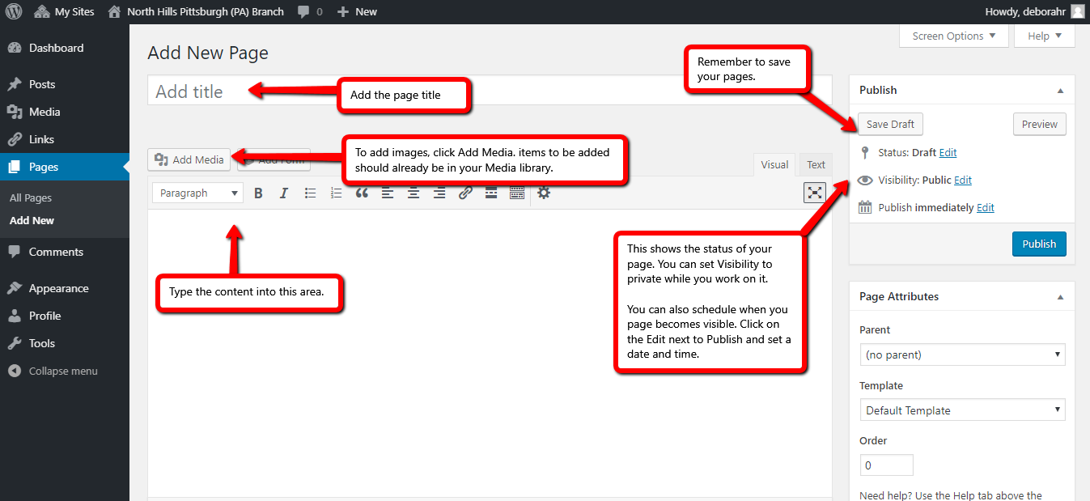
Once you have all of your content on your page, make sure that you Publish it by clicking the blue Publish link on the right.

