Media Library
Any item that you want to add to a page (e.g. newsletter, photo, icon, etc.) must be loaded into your Media Library before it can be inserted.
To add items to your Media Library, click on the Add New link.
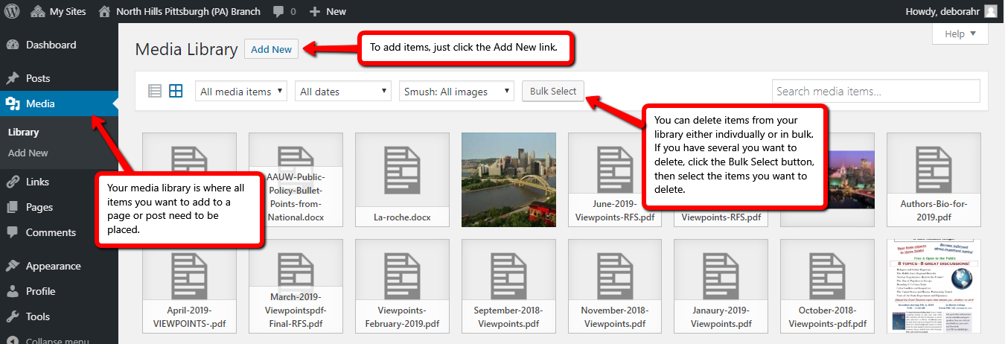
The Add New page allows you to drag and drop an item to your Library or you can click the Select Files link and you will then be able to go out on your computer and select the file or file folder where your item is located. Once you click it on, you will see it drop into the Media Library.
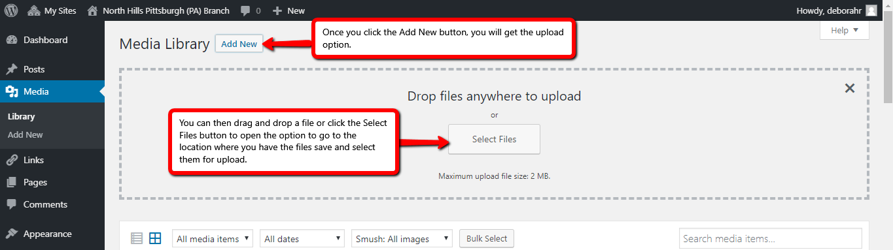
You can delete older items from your Media Library individually or in bulk. To delete several at a time, click on the Bulk Select button and then you can click on multiple images or documents and delete them at one time.

