Appearance Tools
There are two other tools that you will use regularly on your page, these are the Menus and Widgets links.
To access these you will open the Appearances link on the side menu.

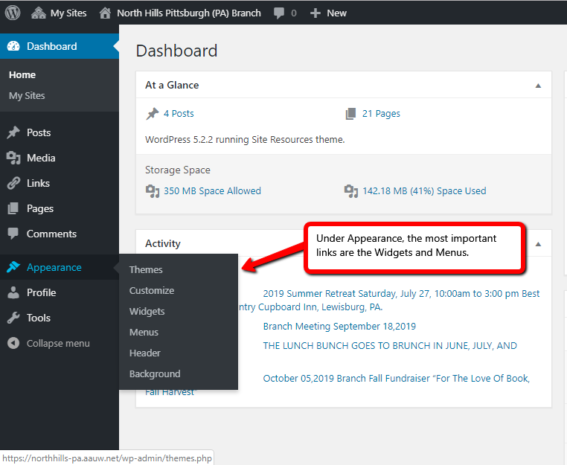

Menus
Menus are the links that appear on your front page and provide navigation to other pages on your site.
When you open the menus link, you will see to main areas…the first list on the left is all your pages and subpages. You will see them in the order in which the page was created, so newer pages appear first in the list.
The middle of the page contains the menu structure. This is how the menus appear on your front page on the menu toolbar which is located immediately below the header.
Here you can see the pages and the subpages under each page. If you want to change the order, you simply put your cursor on it and then drag it to the position you would like it to appear.
For new pages, you need to click on the new page on the left hand column (you will see a little box next to it) and then you can press the Add to Menu button. The new page will appear at the bottom of the menu structure. If you want to move it, just click and drag.

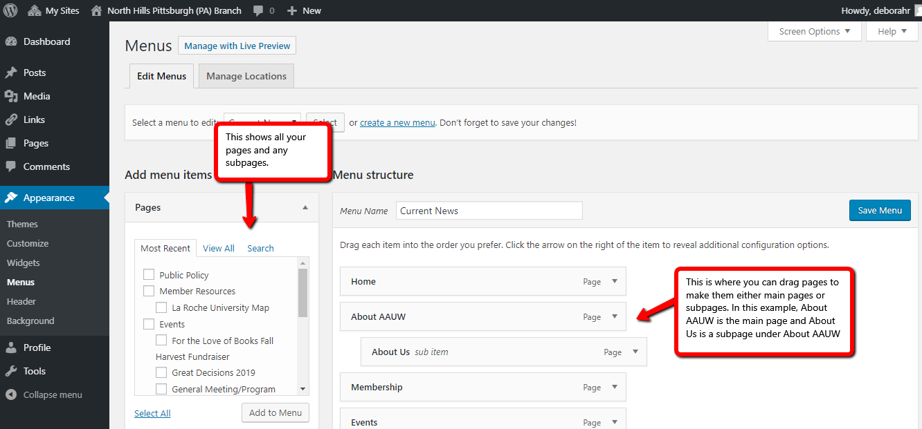

Widgets
Widgets are short applications that you can add to your sidebar menu. When you clock on widgets, you will see the Main Sidebar and the list of widgets on that sidebar.
Currently, you have a Search widget, a Recent Posts widget, a Text widget, an RSS feed widget, and a Links widget. The available widgets are located on the left of the screen. If you want to add a widget, you click it and drag it to your Main Sidebar and drop it. You can drag it around to the order you want it to appear.
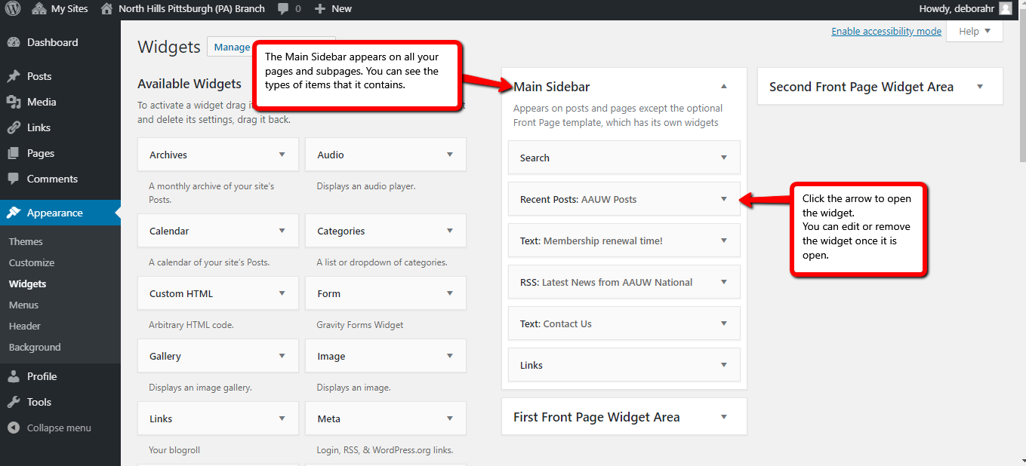
To edit the widgets, just click the down arrow to open the widget, you can then make changes. Be sure to SAVE the changes you make. There is a Save button at the bottom of the widget.

